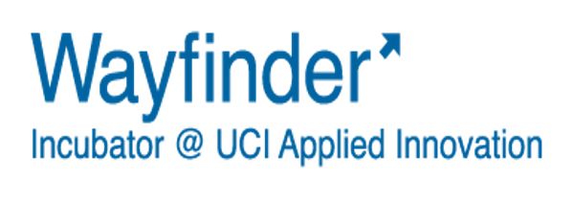
Final Review
Team Submission

Directions: Update your startup GoogleDrive with the latest version of your output portfolio, as well as this completed form by Friday, September 21st, 2018. The information you submit will help the Wayfinder team determine if a Wayfinder extension should be considered for your team. In preparation for your review meeting please send your assigned Final-review EiR , your executive summary, a copy of your pitch deck, and a summary of your progress/challenges to date.
Final Review
Startup Team Name:
Date:
Team Lead:
Team Members:

Please take the time to thoroughly answer each question. You may adjust the formatting as necessary.

- What did you accomplish during this Wayfinder cycle? Detail the progress you made on the milestone goals that you set and describe the current status of your company.

- Please indicate the total amount of funds raised by your company to date (if applicable), its sources (Founders contribution, Inkind, Donation, Competition award, Friends & Family, Grant, Angel investment, VC investment) and the approximate dates in which the funds were received.
Funding Source | Description | Amount | Date
Choose an item.
Choose an item.
Choose an item.

- Are you seeking funding? If so, which types/sources? Specify the amount and how are you planning to use the raised funds.
- Have you applied to other incubators or received offers from other incubators? (Provide details if applicable)

- What are your immediate next steps for your startup?

- Which of the following Applied Innovation resources have you used? Mark all that apply.

- Cove collaborative workspace
- Cove conference rooms
- Cove labs
- Wayfinder workshops
- Wayfinder office hours
- Individual advising meetings with EiRs
- Lunch & Learns
- Other, please specify:

- List and shortly describe the interactions with all the EiRs with whom your team have been directly involved during Wayfinder.

- If you were to be given the opportunity of a Wayfinder cycle extension, provide the 3-5 milestones that you would plan to achieve during that time. Make a case for why your startup should remain in the incubator.

- Which of the following have you accomplished/completed?
- Business Model Canvas
- Minimum Valuable Product, prototype or Beta release
- Evidence of market validation
- Entity formation and capital structure
- Go to market strategy / commercialization plan
- Financial projections
- One page executive summary
- Elevator pitch or elevator pitch video
- Company pitch deck
- Management team bios and advisory board
- Branding (logo, website, business cards)
- Revenue
- Funding
- Cove Fund due diligence draft

